Chapter 16, Problem 102.

Synthesize the transfer function

$$\frac{V_{o}(s)}{V_{in}(s)}=\frac{{10}^{6}}{s^{2}+100s+{10}^{6}}$$

using the topology of Fig. 16.111. Let Y₁ = 1/R₁, Y₂ = 1/R₂, Y₃ = sC₁, Y₄ = sC₂. Choose R₁ = 1 kΩ and determine C₁, C₂ and R₂.

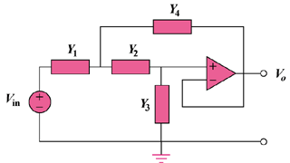

Figure 16.111
For Prob. 16.102.

